Point Inside a Solid

Definition
# Source: AI Source: Provided by: [Data Path: Persons Table -> ID Column: 1, Name_En Column: Motasem Essam] -> From: [ChatGPT] on [7/25/2026]
A Point Inside a Solid is a point that lies strictly within the three-dimensional interior of a solid, without lying on its boundary.
If $P$is a point and $V$is a solid, the containment relationship can be written as:
$$\boxed{P∈int⁡\left(V\right)}$$
This means that $P$is an interior point of the solid.
A solid occupies a three-dimensional region of space and has volume.
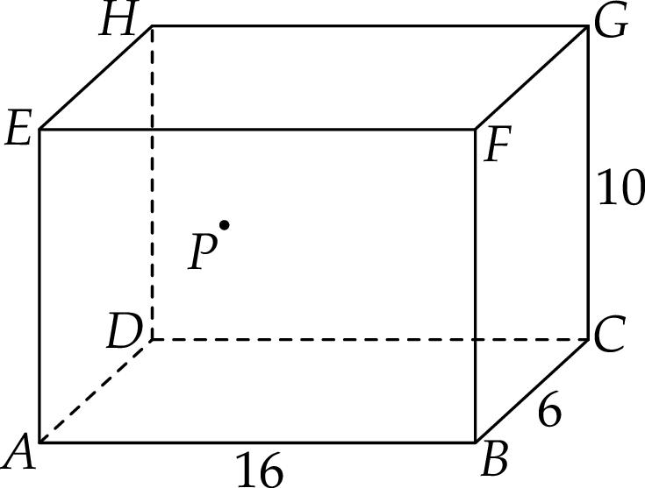
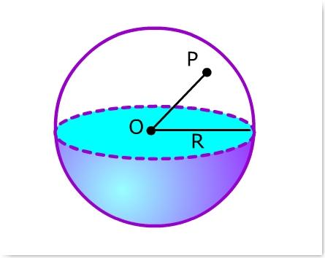
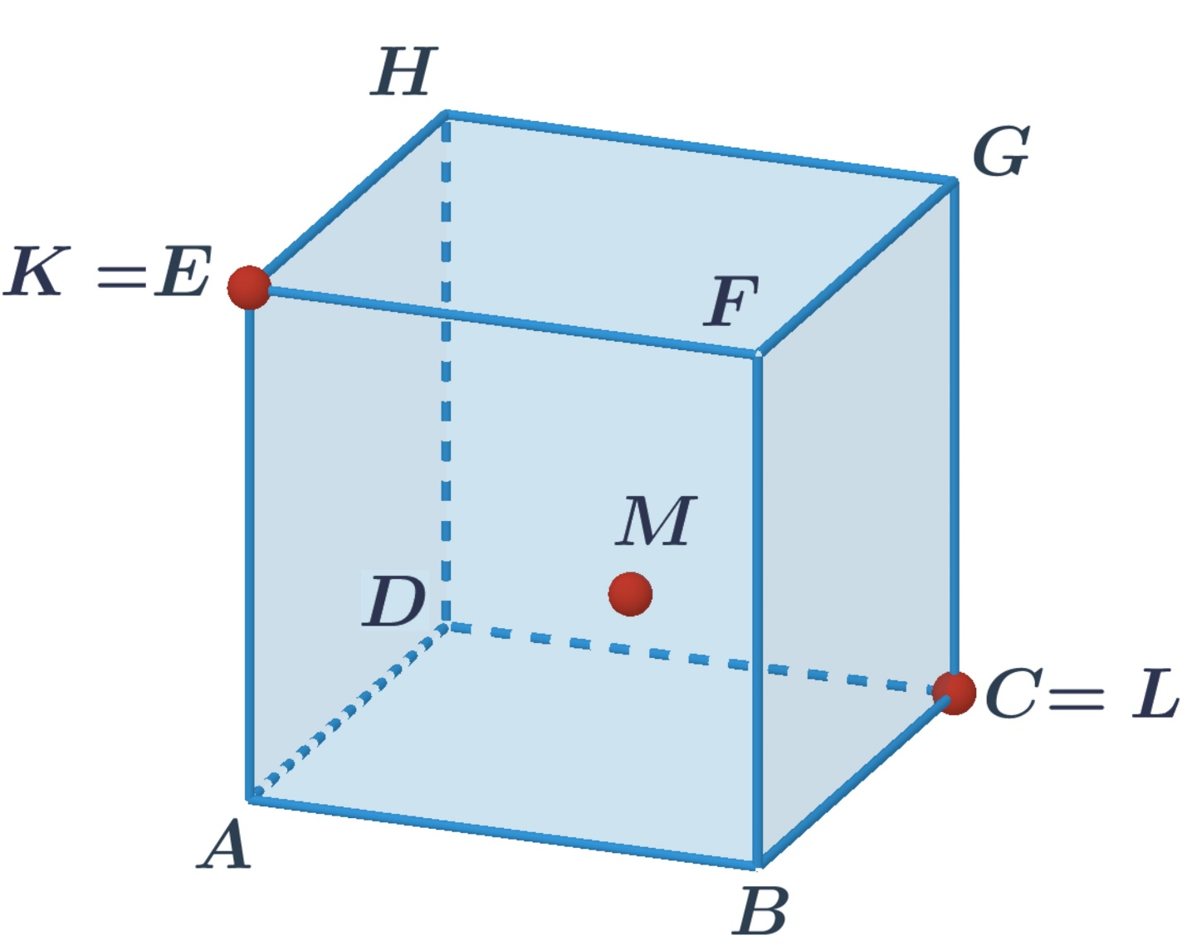
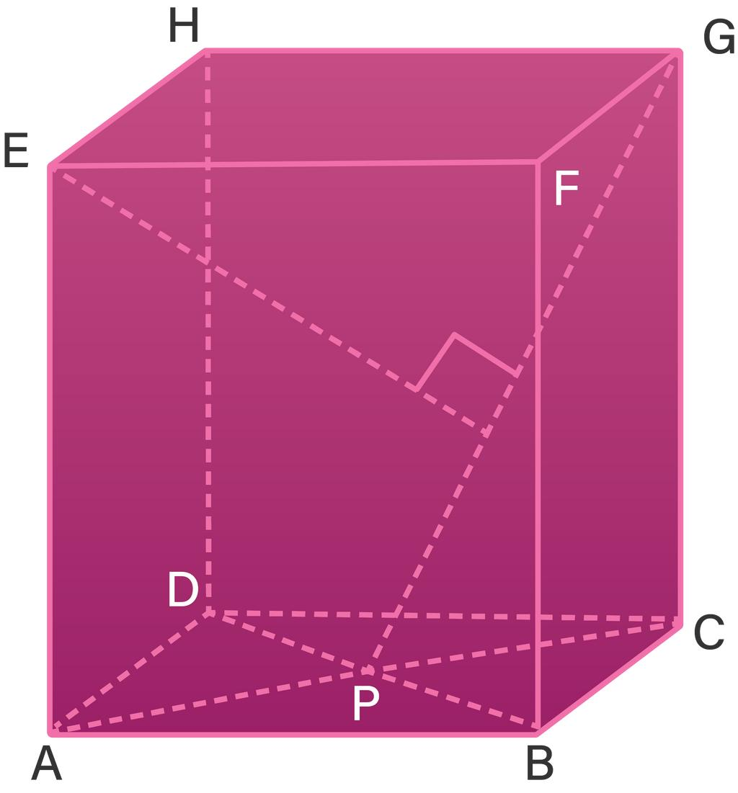
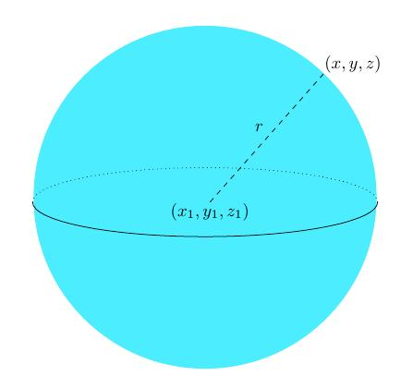
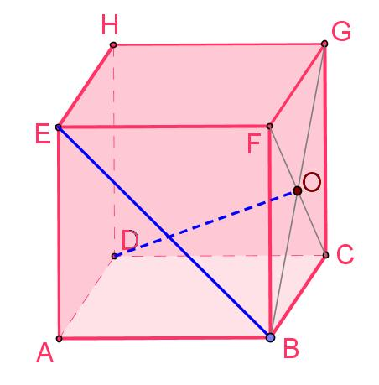

Fundamental Concept
# Source: AI Source: Provided by: [Data Path: Persons Table -> ID Column: 1, Name_En Column: Motasem Essam] -> From: [ChatGPT] on [7/25/2026]
A solid divides three-dimensional space into three positional categories:
- Interior — points strictly inside the solid.
- Boundary — points on the surface enclosing the solid.
- Exterior — points outside the solid.
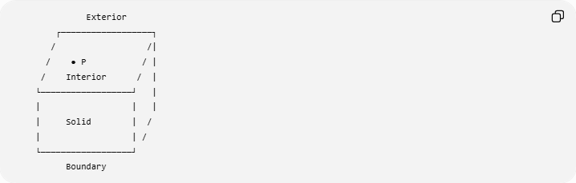
Exterior
┌──────────────────┐
/ /|
/ ● P / |
/ Interior / |
└──────────────────┘ |
| | |
| Solid | /
| | /
└──────────────────┘
Boundary
For a point strictly inside:
$$\boxed{P∈int⁡\left(V\right)}$$

Interior, Boundary, and Exterior
# Source: AI Source: Provided by: [Data Path: Persons Table -> ID Column: 1, Name_En Column: Motasem Essam] -> From: [ChatGPT] on [7/25/2026]
For a solid $V$, we can distinguish:
Point Inside
$$\boxed{P∈int⁡\left(V\right)}$$
Point on the Boundary
$$\boxed{P∈∂V}$$
Point Outside
$$\boxed{P∉V}$$
when $V$represents the closed solid.
The distinction is important because a point can belong to a closed solid while being on its boundary, but a point strictly inside cannot be on the boundary.

Mathematical Representation
# Source: AI Source: Provided by: [Data Path: Persons Table -> ID Column: 1, Name_En Column: Motasem Essam] -> From: [ChatGPT] on [7/25/2026]
A solid can often be described by a three-dimensional inequality.
For example, a sphere of radius $r$centered at the origin has interior:
$$\boxed{x^{2}+y^{2}+z^{2}<r^{2}}$$
The boundary surface is:
$$\boxed{x^{2}+y^{2}+z^{2}=r^{2}}$$
The closed solid sphere is:
$$\boxed{x^{2}+y^{2}+z^{2}≤r^{2}}$$
Therefore:
$$\boxed{\left\{\begin{matrix}x^{2}+y^{2}+z^{2}<r^{2} & \text{inside} \\ x^{2}+y^{2}+z^{2}=r^{2} & \text{boundary} \\ x^{2}+y^{2}+z^{2}>r^{2} & \text{outside}\end{matrix}\right.}$$

Example: Point Inside a Sphere
# Source: AI Source: Provided by: [Data Path: Persons Table -> ID Column: 1, Name_En Column: Motasem Essam] -> From: [ChatGPT] on [7/25/2026]
Consider the solid sphere:
$$x^{2}+y^{2}+z^{2}≤100.$$
The radius is:
$$r=10.$$
Let:
$$P=\left(3 , 4 , 6\right).$$
Calculate:
$$3^{2}+4^{2}+6^{2}=9+16+36=61.$$
Since:
$$61<100,$$
the point lies strictly inside the sphere.
Therefore:
$$\boxed{P∈int⁡\left(V\right)}$$

Example: Point on the Boundary
# Source: AI Source: Provided by: [Data Path: Persons Table -> ID Column: 1, Name_En Column: Motasem Essam] -> From: [ChatGPT] on [7/25/2026]
Consider:
$$x^{2}+y^{2}+z^{2}=100.$$
Let:
$$P=\left(6 , 8 , 0\right).$$
Then:
$$6^{2}+8^{2}+0^{2}=36+64=100.$$
Therefore:
$$\boxed{P∈∂V}$$
The point is on the spherical surface rather than strictly inside the solid.

Example: Point Outside
# Source: AI Source: Provided by: [Data Path: Persons Table -> ID Column: 1, Name_En Column: Motasem Essam] -> From: [ChatGPT] on [7/25/2026]
Let:
$$P=\left(8 , 8 , 2\right).$$
Then:
$$8^{2}+8^{2}+2^{2}=64+64+4=132.$$
Since:
$$132>100,$$
the point is outside the sphere.
Therefore:
$$\boxed{P∉V}.$$

Point Inside Different Types of Solids
# Source: AI Source: Provided by: [Data Path: Persons Table -> ID Column: 1, Name_En Column: Motasem Essam] -> From: [ChatGPT] on [7/25/2026]
The concept applies to many types of three-dimensional solids.

1. Point Inside a Cube
# Source: AI Source: Provided by: [Data Path: Persons Table -> ID Column: 1, Name_En Column: Motasem Essam] -> From: [ChatGPT] on [7/25/2026]
For a cube bounded by:
$$0≤x≤5, \\ 0≤y≤5, \\ 0≤z≤5,$$
a point is strictly inside when:
$$\boxed{0<x<5, 0<y<5, 0<z<5}$$
For example:
$$P=\left(2 , 3 , 4\right)$$
is inside the cube.

2. Point Inside a Rectangular Prism
# Source: AI Source: Provided by: [Data Path: Persons Table -> ID Column: 1, Name_En Column: Motasem Essam] -> From: [ChatGPT] on [7/25/2026]
For a rectangular prism:
$$0≤x≤l, \\ 0≤y≤w, \\ 0≤z≤h,$$
an interior point satisfies:
$$\boxed{0<x<l, 0<y<w, 0<z<h}$$
For example, if:
$$l=10, w=6, h=4,$$
then:
$$P=\left(5 , 3 , 2\right)$$
is strictly inside.

3. Point Inside a Cylinder
# Source: AI Source: Provided by: [Data Path: Persons Table -> ID Column: 1, Name_En Column: Motasem Essam] -> From: [ChatGPT] on [7/25/2026]
Consider a right circular cylinder whose axis is the $z$-axis:
$$x^{2}+y^{2}≤r^{2}$$
with:
$$0≤z≤h.$$
A point strictly inside satisfies:
$$\boxed{x^{2}+y^{2}<r^{2}}$$
and:
$$\boxed{0<z<h}$$
Both conditions are necessary for strict interior containment.
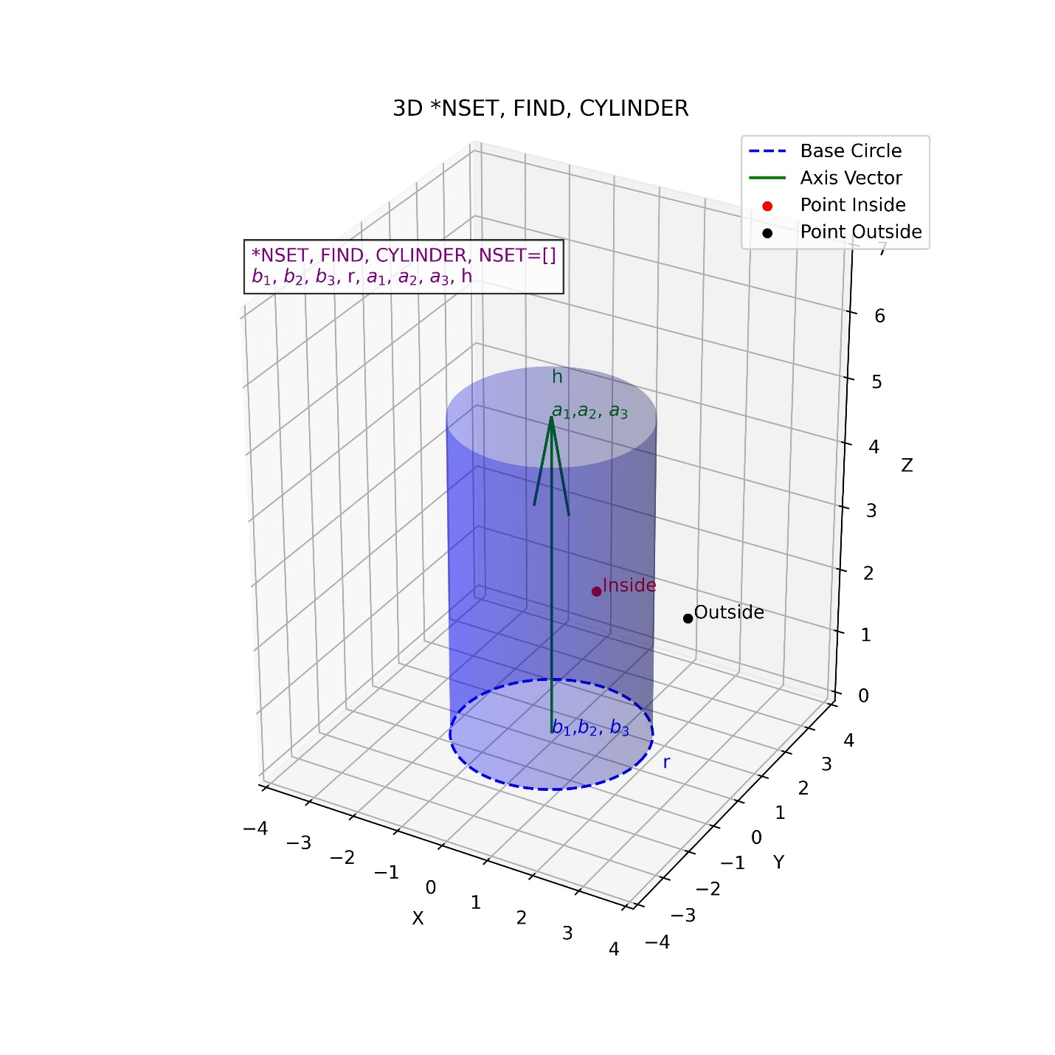
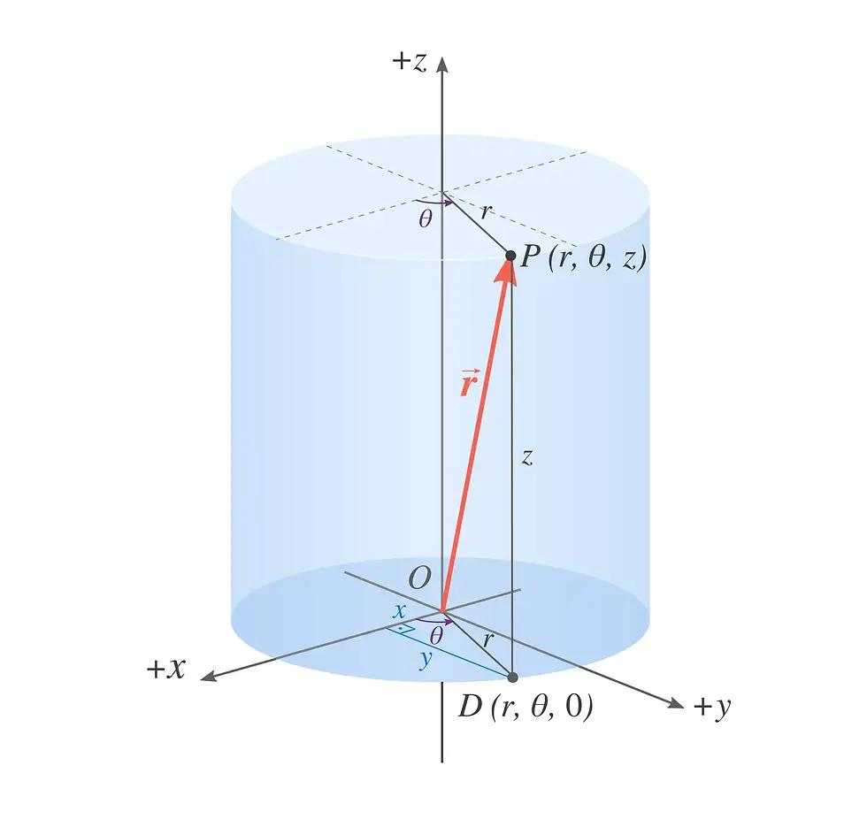
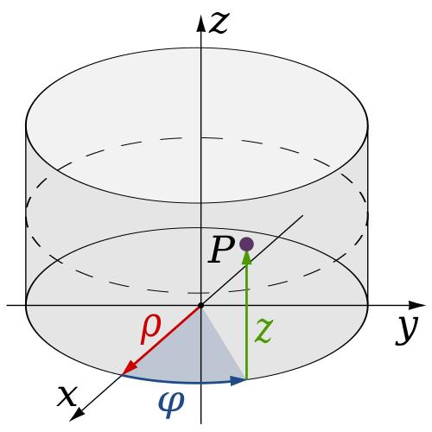
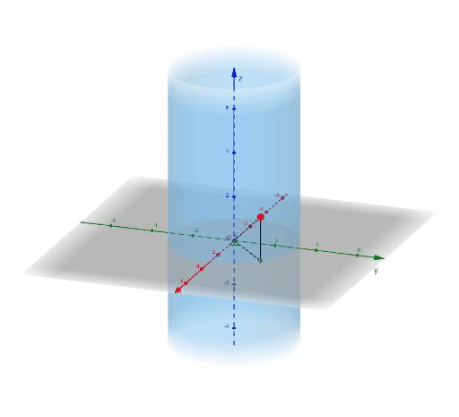
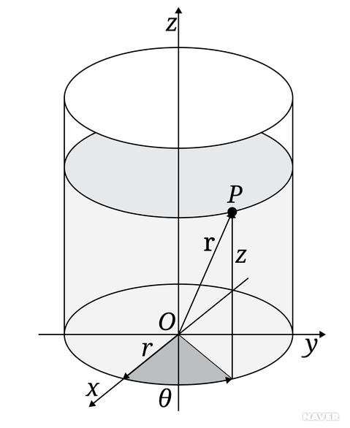

4. Point Inside a Cone
# Source: AI Source: Provided by: [Data Path: Persons Table -> ID Column: 1, Name_En Column: Motasem Essam] -> From: [ChatGPT] on [7/25/2026]
For a right circular cone, the interior consists of points lying within its lateral boundary and between its base and vertex.
The exact inequality depends on the coordinate system and cone orientation.
For example, for a cone with vertex at the origin, axis along the positive $z$-axis, and base at $z=h$:
$$x^{2}+y^{2}≤{\left(\frac{r}{h}z\right)}^{2}, 0≤z≤h.$$
A point strictly inside satisfies:
$$\boxed{x^{2}+y^{2}<{\left(\frac{r}{h}z\right)}^{2}}$$
and:
$$\boxed{0<z<h.}$$

5. Point Inside a General Solid
# Source: AI Source: Provided by: [Data Path: Persons Table -> ID Column: 1, Name_En Column: Motasem Essam] -> From: [ChatGPT] on [7/25/2026]
Not every solid has a simple equation.
For an arbitrary solid $V$, the general mathematical concept is:
$$\boxed{P∈int⁡\left(V\right)}$$
meaning that $P$is an interior point of $V$.
The solid could be:
- a polyhedron,
- sphere,
- cylinder,
- cone,
- irregular engineering object,
- architectural structure,
- or a computational 3D model.

Point Inside a Solid vs Point on Its Surface
# Source: AI Source: Provided by: [Data Path: Persons Table -> ID Column: 1, Name_En Column: Motasem Essam] -> From: [ChatGPT] on [7/25/2026]
This is one of the most important distinctions.
Consider a sphere:
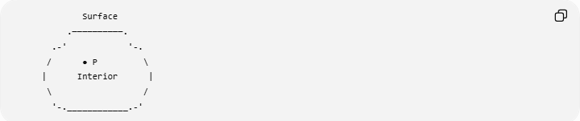
Surface
.──────────.
.-' '-.
/ ● P \
| Interior |
\ /
'-.____________.-'
Point inside:
$$x^{2}+y^{2}+z^{2}<r^{2}$$
Point on surface:
$$x^{2}+y^{2}+z^{2}=r^{2}$$
Thus:
$$\boxed{\text{Interior}≠\text{Boundary Surface}}$$

Point Inside a Solid vs Point Inside a Region
# Source: AI Source: Provided by: [Data Path: Persons Table -> ID Column: 1, Name_En Column: Motasem Essam] -> From: [ChatGPT] on [7/25/2026]
These concepts are analogous but occur in different dimensions.
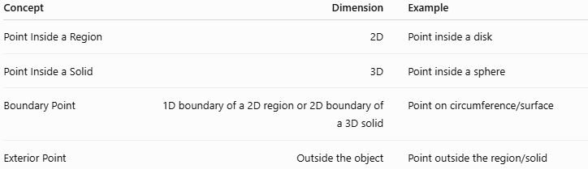
Concept | Dimension | Example
Point Inside a Region | 2D | Point inside a disk
Point Inside a Solid | 3D | Point inside a sphere
Boundary Point | 1D boundary of a 2D region or 2D boundary of a 3D solid | Point on circumference/surface
Exterior Point | Outside the object | Point outside the region/solid
For example:
2D
$$x^{2}+y^{2}<r^{2}$$
describes the interior of a circular region.
3D
$$x^{2}+y^{2}+z^{2}<r^{2}$$
describes the interior of a spherical solid.

Point Inside a Solid vs Point in a Plane
# Source: AI Source: Provided by: [Data Path: Persons Table -> ID Column: 1, Name_En Column: Motasem Essam] -> From: [ChatGPT] on [7/25/2026]
A plane is two-dimensional, whereas a solid occupies three-dimensional space.
A point can be simultaneously:
$$P∈Π$$
and:
$$P∈int⁡\left(V\right).$$
For example, the center of a cube lies in the cube's interior and also lies in any plane passing through that center.
Thus, these are not mutually exclusive relationships.

Point Inside a Solid vs Point on a Surface
# Source: AI Source: Provided by: [Data Path: Persons Table -> ID Column: 1, Name_En Column: Motasem Essam] -> From: [ChatGPT] on [7/25/2026]
A solid can be bounded by one or more surfaces.
For example:
$$\text{Sphere solid}=\text{interior}+\text{spherical boundary}.$$
Therefore:
$$\boxed{V=int⁡\left(V\right)∪∂V}$$
for a typical closed solid.
A point inside satisfies:
$$P∈int⁡\left(V\right),$$
while a boundary point satisfies:
$$P∈∂V.$$

Topological Interpretation
# Source: AI Source: Provided by: [Data Path: Persons Table -> ID Column: 1, Name_En Column: Motasem Essam] -> From: [ChatGPT] on [7/25/2026]
In mathematics, $P$is an interior point of a solid $V$if there exists some positive radius $ε$such that the entire open ball centered at $P$remains inside $V$:
$$\boxed{B\left(P , ε\right)⊂V}$$
for some:
$$ε>0.$$
In simple terms:
If you move a sufficiently small distance in any direction from an interior point, you remain inside the solid.
A boundary point does not have this property because moving slightly toward the exterior can leave the solid.

Distance from an Interior Point to the Boundary
# Source: AI Source: Provided by: [Data Path: Persons Table -> ID Column: 1, Name_En Column: Motasem Essam] -> From: [ChatGPT] on [7/25/2026]
For an interior point $P$, the distance to the boundary is positive:
$$\boxed{d\left(P , ∂V\right)>0}$$
For a boundary point:
$$\boxed{d\left(P , ∂V\right)=0}$$
This provides another mathematical distinction between an interior point and a boundary point.
For a sphere, if $P$is at distance $OP$from the center and:
$$OP<r,$$
then $P$is inside.

Closed and Open Solids

Open Solid
# Source: AI Source: Provided by: [Data Path: Persons Table -> ID Column: 1, Name_En Column: Motasem Essam] -> From: [ChatGPT] on [7/25/2026]
An open solid contains its interior but excludes its boundary.
For a sphere:
$$\boxed{x^{2}+y^{2}+z^{2}<r^{2}}$$

Closed Solid
# Source: AI Source: Provided by: [Data Path: Persons Table -> ID Column: 1, Name_En Column: Motasem Essam] -> From: [ChatGPT] on [7/25/2026]
A closed solid contains both its interior and boundary:
$$\boxed{x^{2}+y^{2}+z^{2}≤r^{2}}$$
Thus, when discussing strictly inside, the appropriate condition is normally:
$$\boxed{x^{2}+y^{2}+z^{2}<r^{2}}.$$

Relationship with Containment
# Source: AI Source: Provided by: [Data Path: Persons Table -> ID Column: 1, Name_En Column: Motasem Essam] -> From: [ChatGPT] on [7/25/2026]
Point-inside-solid containment is a special case of geometric containment.
If:
$$P∈int⁡\left(V\right),$$
then $P$is contained within the solid.
However, the point is not itself a solid.
The relationship is between objects of different dimensions:
$$\boxed{\text{Point}⊂\text{Solid}}$$
in the set-theoretic sense when the point belongs to the solid.

Relationship with Related Concepts
# Source: AI Source: Provided by: [Data Path: Persons Table -> ID Column: 1, Name_En Column: Motasem Essam] -> From: [ChatGPT] on [7/25/2026]
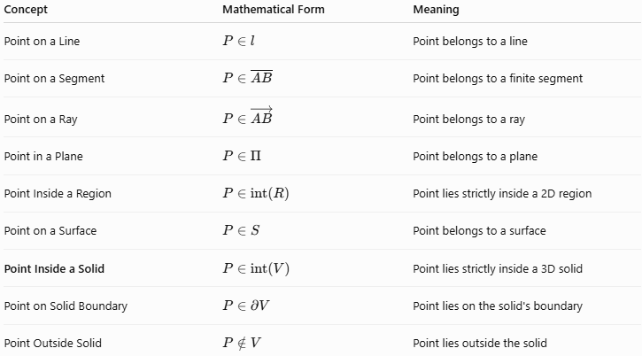
Concept | Mathematical Form | Meaning
Point on a Line | $$P∈l$$ | Point belongs to a line
Point on a Segment | $$P∈\overset{‾}{AB}$$ | Point belongs to a finite segment
Point on a Ray | $$P∈\vec{AB}$$ | Point belongs to a ray
Point in a Plane | $$P∈Π$$ | Point belongs to a plane
Point Inside a Region | $$P∈int⁡\left(R\right)$$ | Point lies strictly inside a 2D region
Point on a Surface | $$P∈S$$ | Point belongs to a surface
Point Inside a Solid | $$P∈int⁡\left(V\right)$$ | Point lies strictly inside a 3D solid
Point on Solid Boundary | $$P∈∂V$$ | Point lies on the solid's boundary
Point Outside Solid | $$P∉V$$ | Point lies outside the solid

Dimensional Containment
# Source: AI Source: Provided by: [Data Path: Persons Table -> ID Column: 1, Name_En Column: Motasem Essam] -> From: [ChatGPT] on [7/25/2026]
The point-containment concepts you have been building can be organized by the geometric object containing the point:
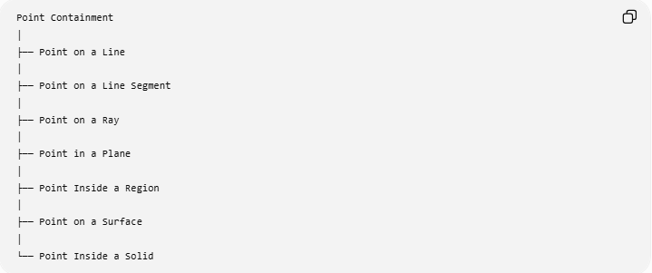
Point Containment
│
├── Point on a Line
│
├── Point on a Line Segment
│
├── Point on a Ray
│
├── Point in a Plane
│
├── Point Inside a Region
│
├── Point on a Surface
│
└── Point Inside a Solid
This creates a useful progression:
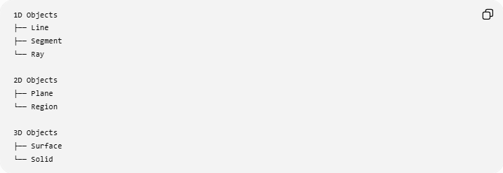
1D Objects
├── Line
├── Segment
└── Ray

2D Objects
├── Plane
└── Region

3D Objects
├── Surface
└── Solid

Key Points
# Source: AI Source: Provided by: [Data Path: Persons Table -> ID Column: 1, Name_En Column: Motasem Essam] -> From: [ChatGPT] on [7/25/2026]
- A Point Inside a Solid lies strictly within the three-dimensional interior of a solid.
- The standard notation is:
$$\boxed{P∈int⁡\left(V\right)}.$$
- An interior point does not lie on the boundary.
- A solid has three-dimensional extent and occupies volume.
- For a spherical solid:
$$x^{2}+y^{2}+z^{2}<r^{2}$$
describes its interior.
- Equality:
$$x^{2}+y^{2}+z^{2}=r^{2}$$
describes the boundary surface.
- For a closed spherical solid:
$$x^{2}+y^{2}+z^{2}≤r^{2}.$$
- An interior point has a positive distance from the boundary:
$$d\left(P , ∂V\right)>0.$$
- Point-inside-solid containment is a 3D geometric containment relationship.
- The concept applies to spheres, cubes, rectangular prisms, cylinders, cones, polyhedra, and irregular solids.
- It is fundamental in solid geometry, analytic geometry, computational geometry, CAD, 3D modeling, GIS, robotics, and collision detection.

Conclusion
# Source: AI Source: Provided by: [Data Path: Persons Table -> ID Column: 1, Name_En Column: Motasem Essam] -> From: [ChatGPT] on [7/25/2026]
Point Inside a Solid describes the containment relationship in which a point lies strictly within the three-dimensional interior of a solid. It is distinct from a point on the solid's boundary and from a point outside the solid. Mathematically, an interior point can be represented by $P∈int⁡\left(V\right)$, while specific solids can be tested using inequalities. This concept completes the main point-containment categories from lines, segments, and rays through planes and regions to surfaces and three-dimensional solids.

